1.Write a pig script to find the minimum temperature observed in a given weather station in a particular year.

RUNNING PIGSCRIPT

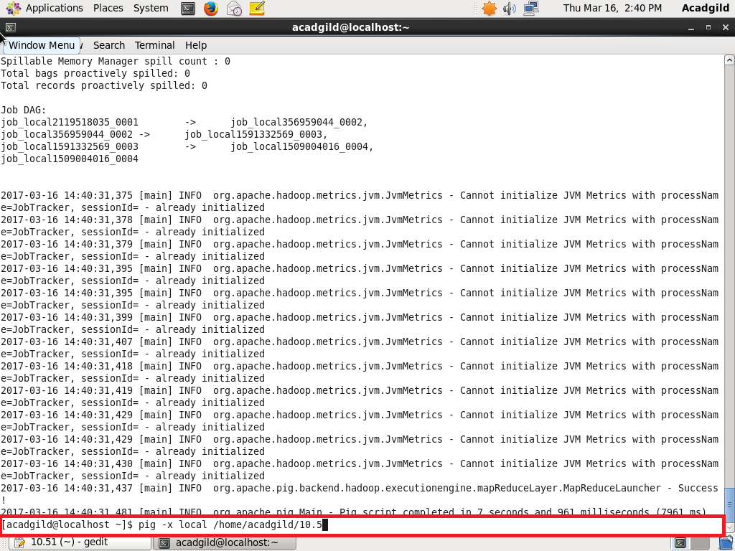

INPUT AND OUTPUT

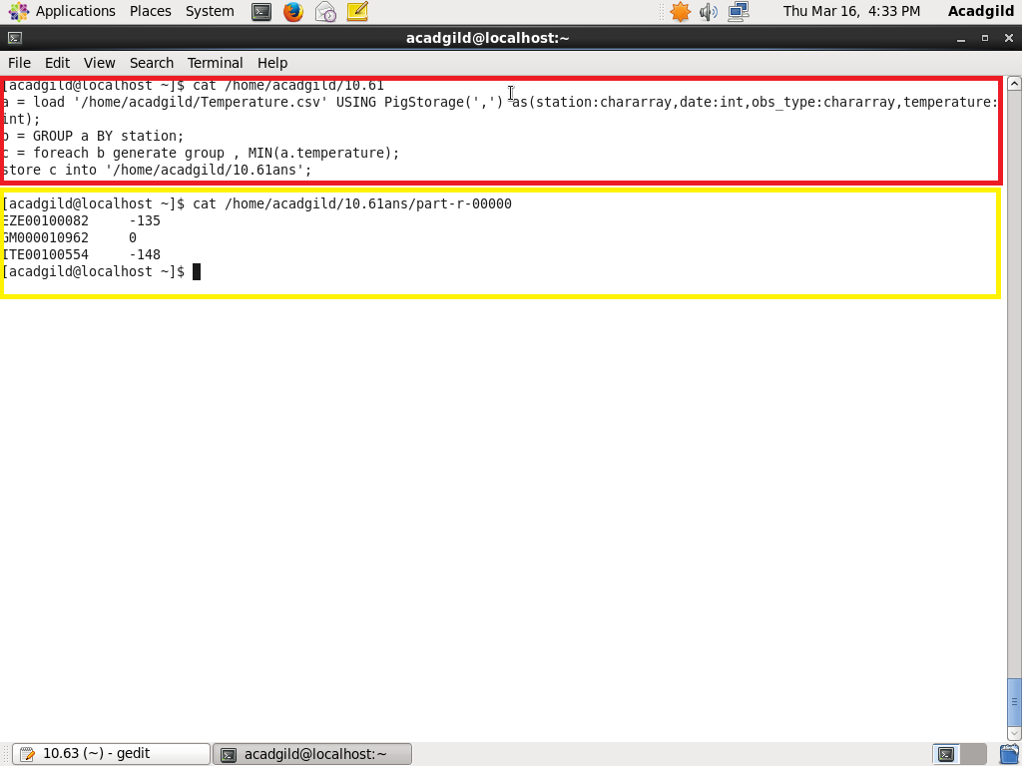

2. Write a pig script to find the maximum temperature observed in a given weather station in a particular year.

INPUT AND OUTPUT

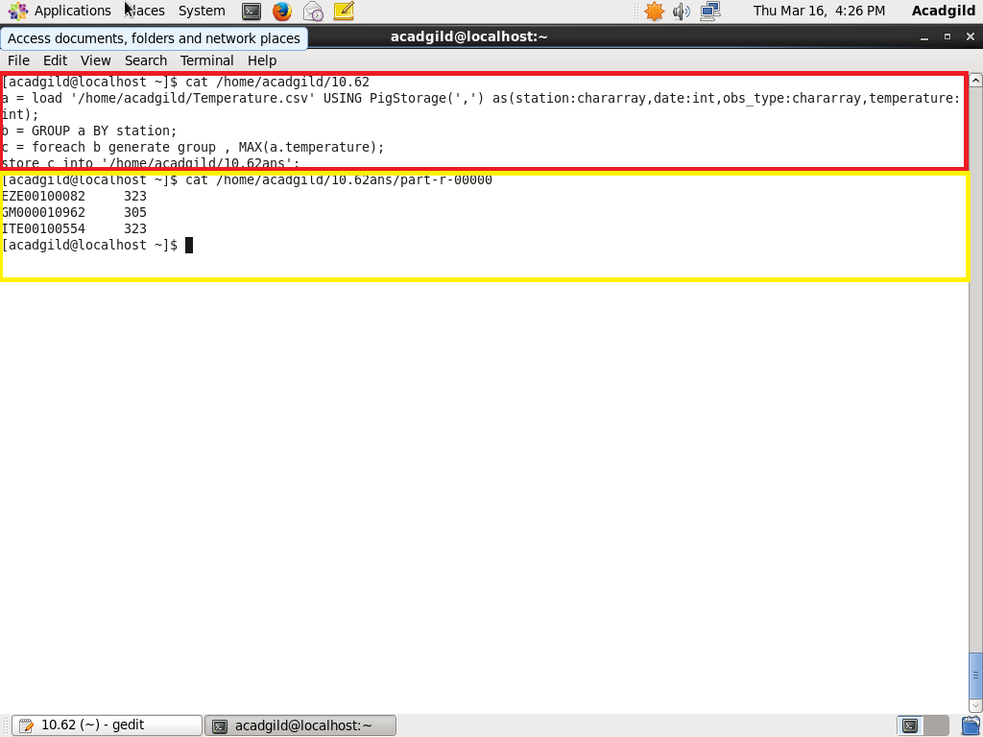

3. Write a pig script to find the number of readings given by each weather station according to the dataset.

INPUT AND OUTPUT

